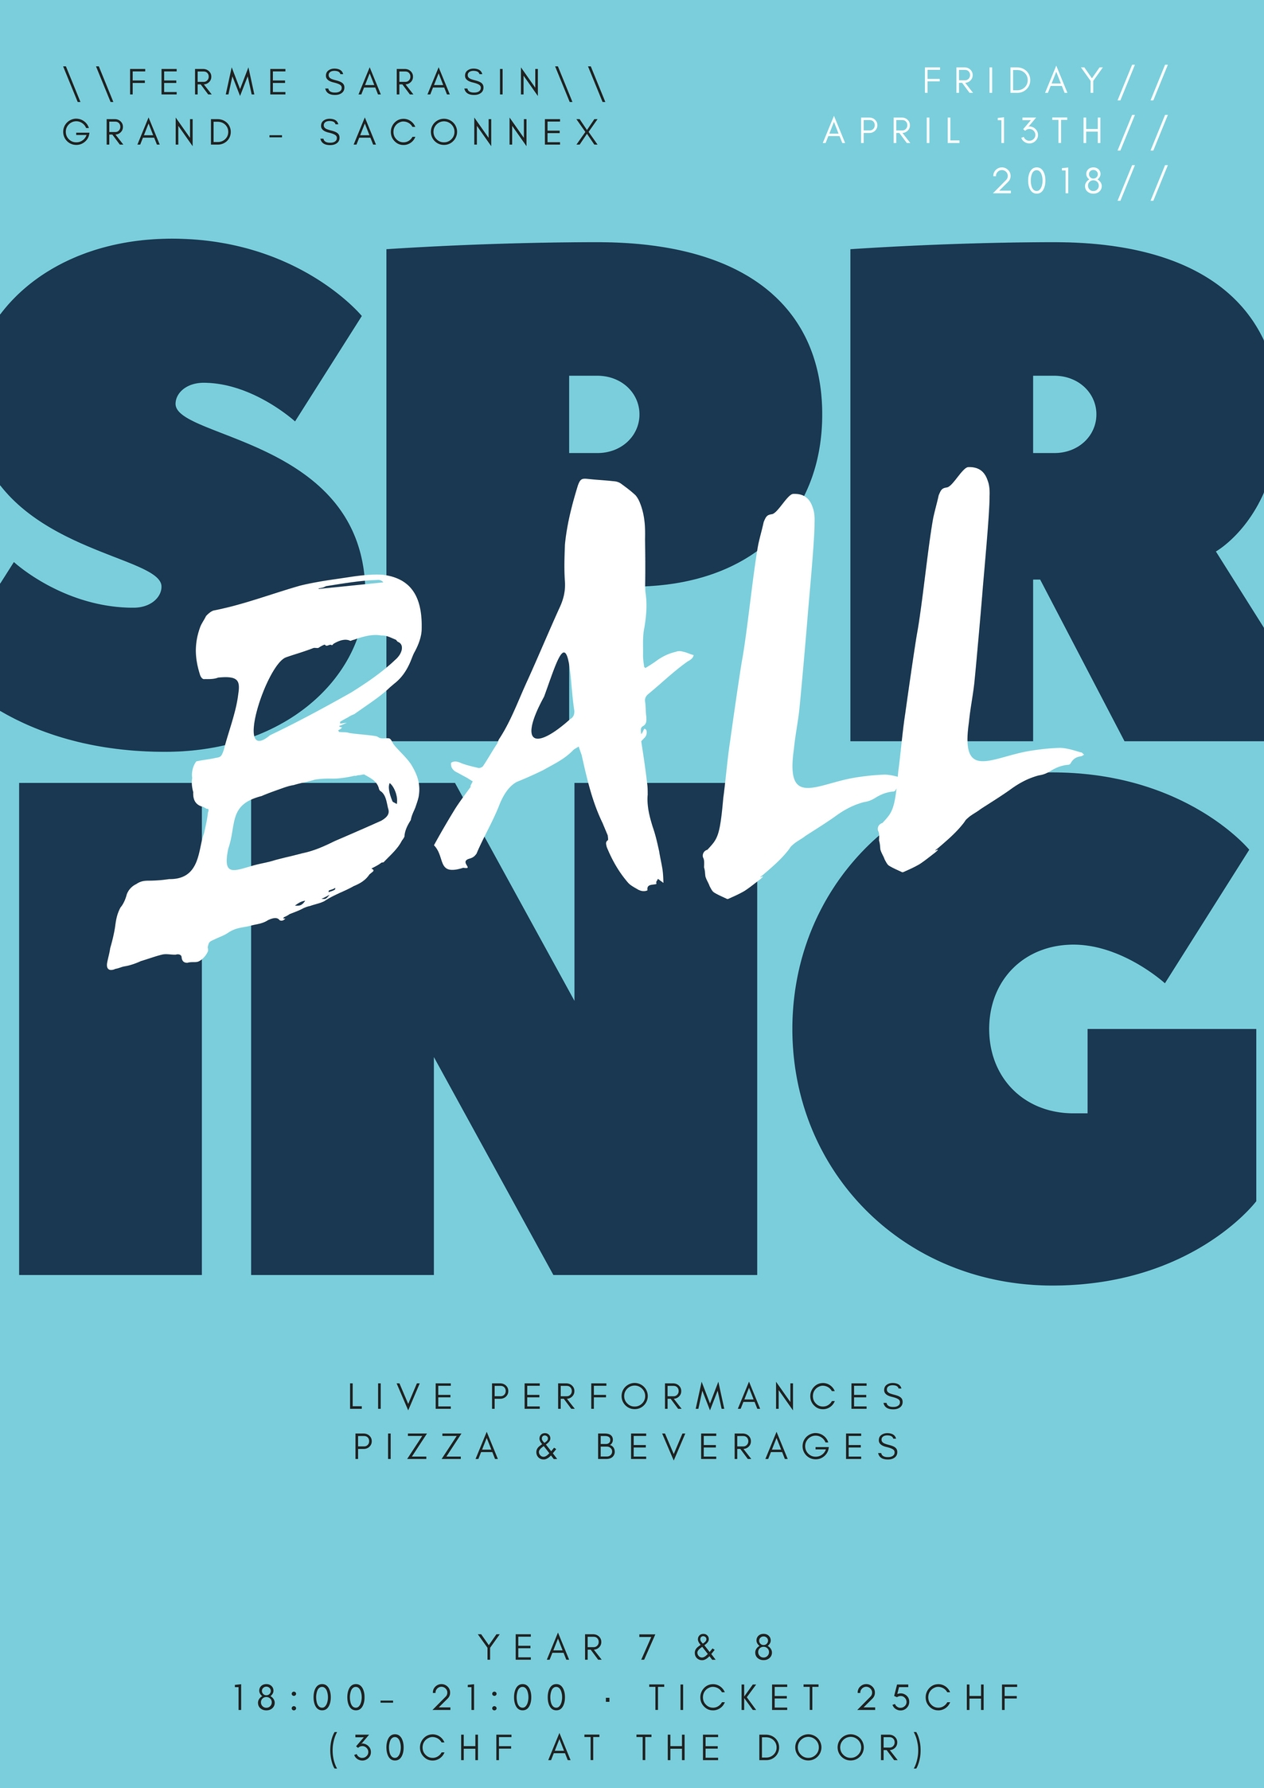
Dear Parents,

The Student Council is pleased to announce that the Spring Ball will take place this year at the Ferme Sarasin on the 13th of April 2018.

When: Friday April 13th (18:00-21:00)
Where: Ferme Sarasin, Chemin Edouard-Sarasin 47 1218 Le Grand-Saconnex
Dress Code: Formal
Price of ticket: 25 CHF

The ball will take place in the Ferme Sarasin, a renovated 19th century farm, now used for hosting events by the city of Grand-Saconnex. This event is open only to Nations Year 7 and 8 students. Students must bring their school ID card and a valid ticket to be allowed entry, and will not be readmitted to the ball after exiting. It is not an official school event, but staff will be present (homeroom teachers).

Please note that all normal school rules, including the Code of Conduct, apply. No responsibility is taken for students’ arrival or departure, or any occurrence outside the Spring Ball. Parents will be responsible for their child’s behavior at all times and may be called at any time to pick them up from the dance. Inappropriate behavior includes, but is not limited to: use of forbidden substances (including drugs and alcohol); aggressive behavior or language; refusal to allow their bag or coat to be searched; etc. The events are alcohol-free and it is stressed that any attempt to bring alcohol into the dance or arrival in an unfit state or improperly dressed will render the student(s) involved liable to exclusion from the dance without refund, and further disciplinary action.

If your child wishes to attend the Spring Ball, please sign the permission form below. Your child must present a signed permission slip and pay an entry fee of 25 CHF to be allowed into the ball. Food and drinks will be provided as well as Live music performances. Tickets will be sold from the 9th to the 13th (cafeteria at break times) and also upon entrance to the event for 30 CHF.

If you or your child have any questions, feel free to contact the student council at osamu.okuma@learning.ecolint.ch or nationsstudentcouncil@gmail.com

Regards,
Ecolint Student Council

I, _______________________________, give permission for my child to attend the Year 7 & 8 Spring Ball.
Child’s name: ______________________________________
Homeroom: ____________
Home telephone number: _____________________________________
Parents’ mobile number: __________________________________________

I have read and accepted the regulations and conditions above.
Signature of parent: ____________________________________
Date: ____________
Signature of student: ___________________________________
Date: ____________

